Action at UPIR Heats up on Cold Day
Local Drivers Compete Against Each Other, NASCAR Driver Ken Schrader

UPIR opened it’s racing season this past Friday and Saturday night’s in a two day event packed full of on-track action. The biggest story of the weekend, however, was not the on-track action, but who was competing in the Modified division. NASCAR driver Ken Schrader made an appearance at the racetrack Saturday night to partake in the jam packed modified show that saw almost 20 modifieds competing to make it into the main show. UPIR was not the only track that Schrader competed at Saturday. In fact, Ken began his day in Toledo, Ohio qualifying his car for Sunday’s ARCA Series event at Toledo Speedway. As soon as Ken finished his two laps in Toledo, he jumped on a plane, and flew to the Delta County Airport in Escanaba, flying over the UPIR track in the process to the appreciation of the fans. Ken was then taken to the track in style, riding in a 1950’s classic car, and within minutes was in his number 9 Federated Auto Parts Modified on track in his heat race.

Racing began on a cold and cloudy Friday night, with all of the divisions, excluding the Modifieds, racing in heat races to determine who would make the features, and who would have to try again in the last chance qualifying race. The Street Stocks took to the track first, opening the night with two heat races. The first heat was won by Ron Bochert, followed by Rob Willis and Matt Adams. The second heat was won by Ron Jenshak, with Paul Wagner coming in second, and Jeff Sullivan in third. The 500 Micro Sprint Class took to the track next, running only one heat which saw Kyle Getchell win, Paul Hosking finish second, and Kristy Peterson coming home third. The more powerful 600 Micro Sprints came out next, running three heats. The first heat was won by defending track champion Matt Peterson, followed in second by Scott Ruleau and in third by Jeff Ives. Heat two was won by Jay Baumler with Scott Degnan second and Todd Belanger third. Heat three was won by Gregg Brayak, with second going to Steven Miller, and third going to Brent Smith. The next heat race was run by the Junior Micro Sprint and was won by Ty Springer, with Logan Getzloff in second and Dylan Larsen in third. The final class to take to the quarter-mile track Friday was the Sport Fours, a class comprised of four cylinder cars. The next heat race was run by the Junior Micro Sprint and was won by Ty Springer, with Logan Getzloff in second and Dylan Larsen in third. The Sport Fours ran four heats, the first of which was won by Robbie Iverson with Kirk Millette in second and Bryn Beauchamp in third. The second heat found Ethan Thomma victorious with Justin Lauscher and David Martin placing behind him. Heat three was taken by Erik Marenger, followed in second by Elliot Reid in second and Dylan Lanaville in third. The final heat race of the night was won by Cory Corwin, with Cody Johnson finishing second and Jon Pepin finishing third

Saturday brought not only the sun and warmer temperatures, but also more racing action. The on-track activities began with the last chance qualifying races for each of the classes, excluding the Modifieds who ran heats and their feature later in the evening. Before any of the LCQ races took place, however, the Junior Micro Sprints took to the track for their feature race. Eventual winner, Ty Springer, played the race smart, staying patient, and waiting for the white flag before making his pass for the lead, and win of the race. Second place went to Logan Getzloff, with Dylan Larsen in third. Next on the track were the 500 Sprints for their feature race. After 20 laps, Kyle Getchell took the win with Kristy Peterson second and Gabriel Zellnar third. An ecstatic Jesse Liss finished fourth, beating sister Justina to the line. The 600 Sprints ran their LCQ next, which was won by Bart Kostreva, second went to Gary Gregory, and third was Christian Groleau. The LCQ for the Sport Fours came on to the track next and ended with a Stemick one-two finish, with Bryon winning and Kyle finishing second. Third place went to Mike Montie. The Modifieds took to the track for three heats, however, waiting for the arrival of Ken Schrader, the Street Stocks Feature was run to give Ken a few moments to get ready and settle. The Street Stock Feature was won by Rob Willis, followed by Ron Jenshak, and in third Matt Adams. The first Modified heat was won by Chris Pepin, second was Dale Peterson, and third Matt Valiquette. The second heat went to Jeremy Hanson, with Jim Hanson in second, and Fran Berube in third. At this point the Street Stock Feature was run as Ken Schrader pulled into the track. After taking three practice laps in his Federated Auto Parts Modified, Schrader and the rest of the drivers were ready to run their heat. Schrader, leading flag to flag, won the heat, followed by Eric Arenson and Greg Bruce.

Before the final three features were run, those being for the Modifieds, 600 Sprints, and Sport Fours, n intermission was held. During the break, the Modified drivers parked along the frontstretch for driver introductions as the 50/50 raffle, and usual kids’ bikes drawings were held. After the drivers were introduced, a quick interview was held with Ken Schrader, in which he discussed his busy day, the advancement of the sport, and his main goal, “Not hitting anything too hard.” The drivers then climbed into their cars, the command was given to start their engines, and the Modified feature was ready to go. The 25 lap race was littered with caution flags, as the O’Reilly Yellow Flag waving numerous times before the conclusion. After starting 11th, Ken Schrader methodically moved his way through the field, eventually taking the lead and the win. Fighting hard to a second place finish was Chris Pepin, with defending track champion Dale Peterson finished third. After the Modifieds went back to the pit area, the 600 Micro Sprints came out for their feature. The 20 lap race was won by Jared Cech, with Scott Ruleau in second, and Josh Bartel finishing third. The last race of the evening was the Sport Fours’ feature. After a relatively clean 20 lap race, Mike Montie took home the win. Second place went to Erik Marenger, with the third position going to Jon Pepin.

The opening event to the 2014 UPIR season was two days full of excitement, setting the tone for the rest of the year. The next race day is June 7, with racing starting at 6 PM EST, gates will open at 5 PM EST. UPIR would like to thank all of their sponsors for their continued support, and especially the Island Resort and Casino for sponsoring the appearance of Ken Schrader.

By - UPIR Race Reporter/ Co-announcer Todd Rose

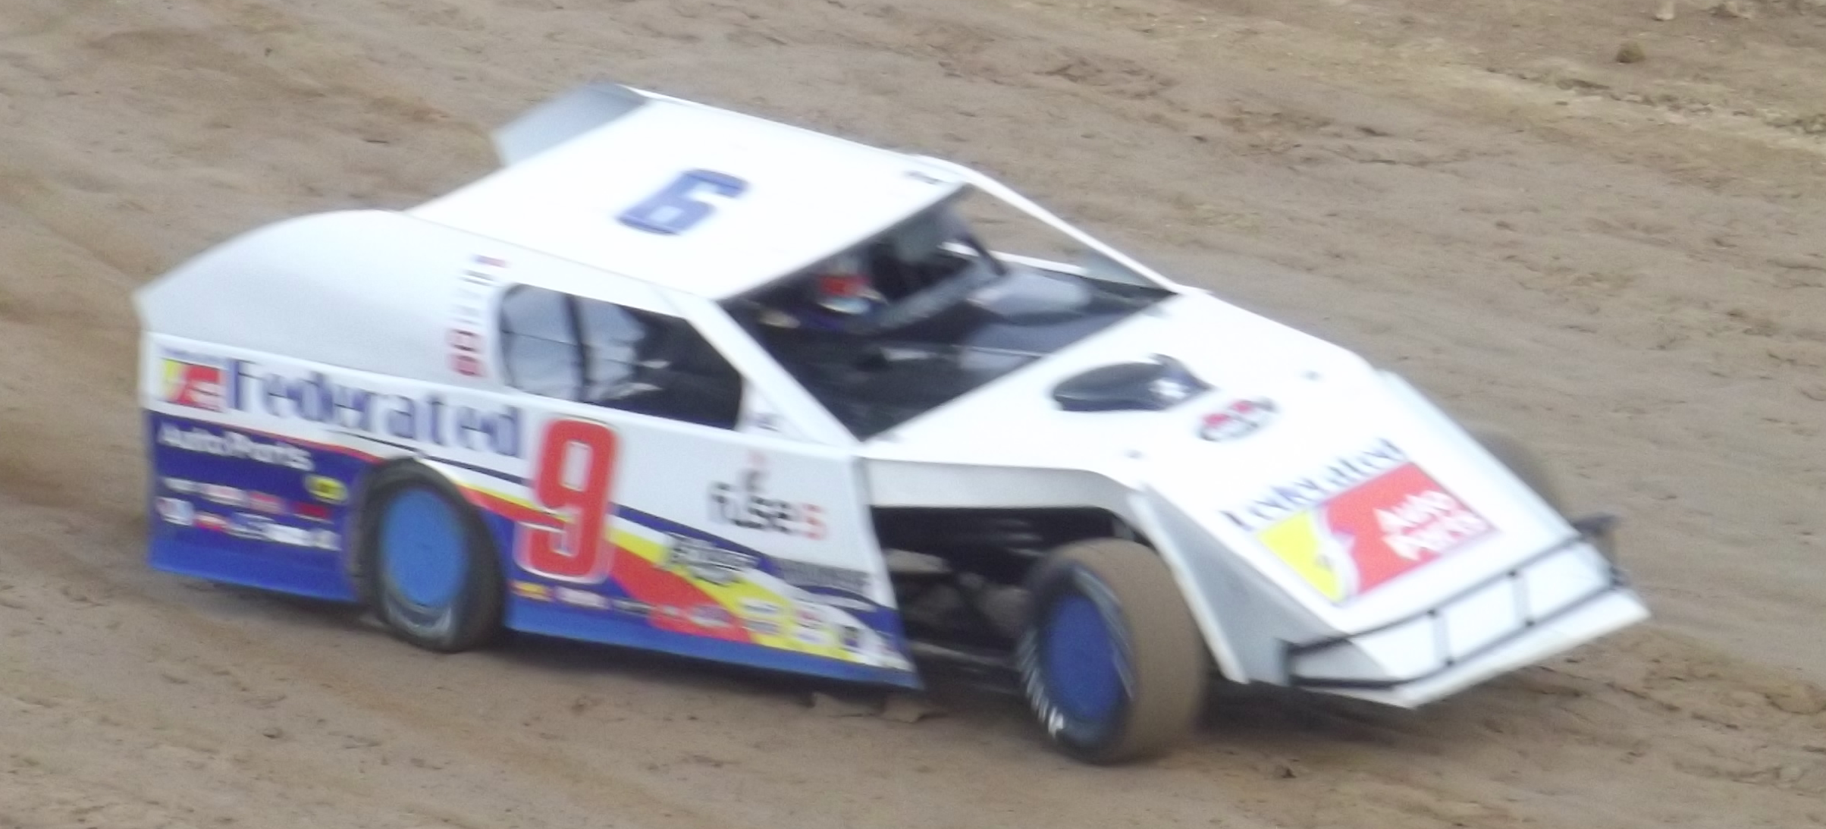
Ken Schrader wheeling his modified around the UPIR track

